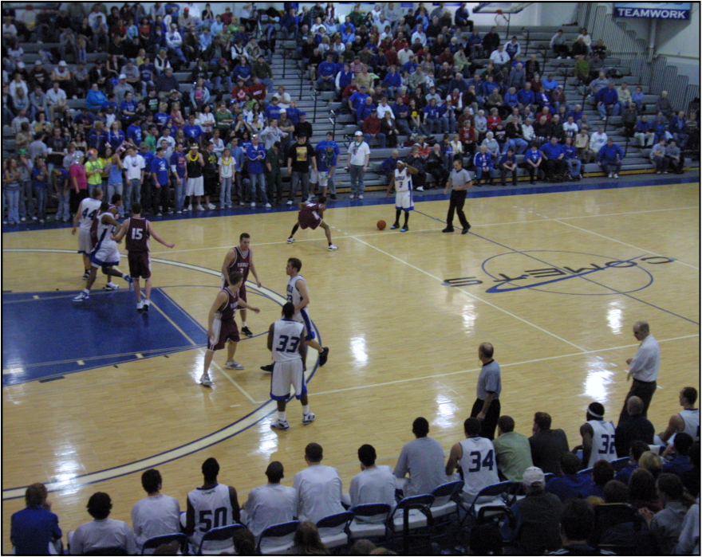
Mayville State University Women’s Basketball Trademarks
2020-2021

1. COMETS FIRST
Unselfish Trustworthy
WE before me Where can I help????
Love for each other Sacrifice for the welfare of the Department
See the need, fill the need
Discipline Accept your role, fill your role

2. SERVANTHOOD
Serve others Maximize your gifts and use them to serve others
Courteous/Polite/Respect Thank You Notes
NBA (Next Best Action) Help custodians, pick up trash
Sportsmanship Respect the game, opponents, facilities and officials

3. COMMUNICATION
Effective Communication Hardest working team on our schedule
Thank You Notes Get over being cool
We earn everything we get We deserve to win
Stay the course, perseverance Build your house on solid ground

4. FUNDAMENTALS
Defense Offense
Transition and Talk Sureness
Stance, Vision, Position, Talk Triple Threat – Rim, Post, Action
Ball Pressure Doleac
On and Up the line Ball handling
Closeouts Feeding the post
High Hands Cut and Space
Shot pressure Drive and Space
BOPCRO Get it up, get it straight, follow through

5. STUDENTS/TEACHERS OF THE GAME
Students of the game, students of life Teachers of the game
Notebooks Camps
Active and teaching bench Players teach players (vets teach rookies)
Take time to examine and reflect What can I learn from this experience/situation?

6. COMMUNICATION
Positive and Encouraging Enthusiasm
Control the rudder that steers the ship Posts demand the ball
Echo yells Our system of talk
With professors/Grade checks Sign-in sheet

7. CONSTANT IMPROVEMENT
Sense of urgency Growth
Buy in Attention to detail
Discipline We warm up with a purpose
Desire to improve Desire to succeed
Definition of Success Kaizen

