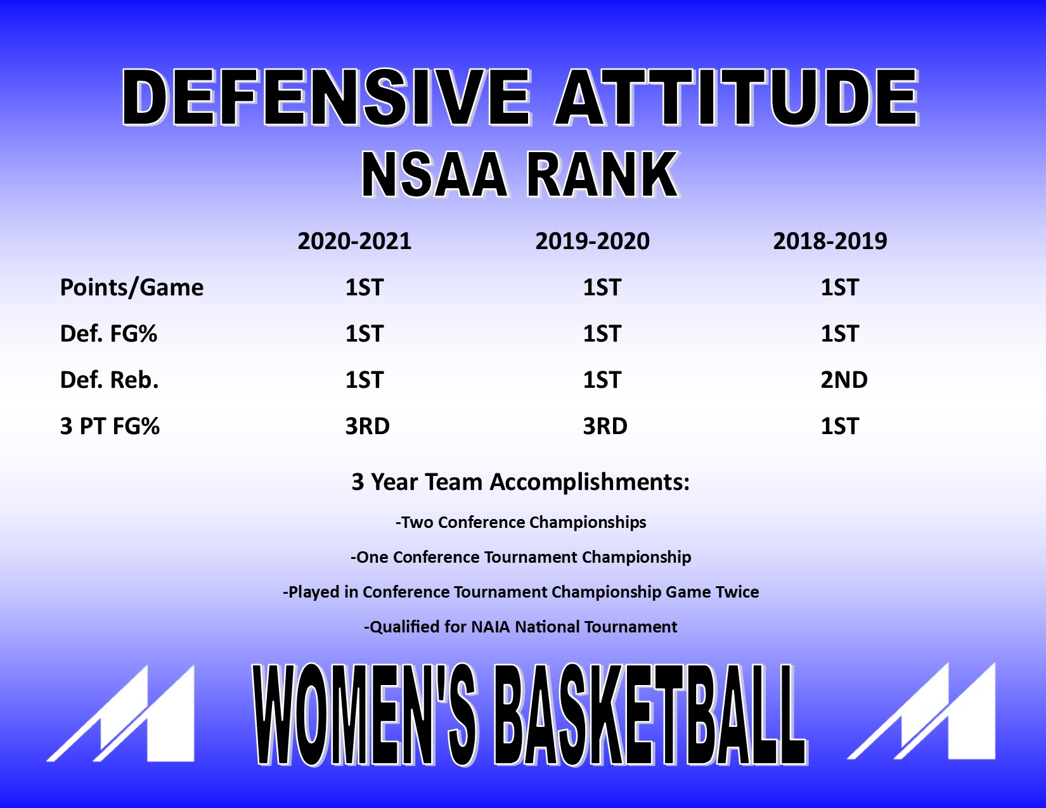

Defensive Rules
- NO Lay Ups
- NO 3’s
- NO Second Shots

3 Phases of Defense on Every Pass/Catch
- On the Ball
- Off the Ball
- Post Defense – Sometimes and 1 & 3 will combine when the post defends the ball

Phase 1 - On the Ball – “How did you get to the ball, determines how you defend the ball”
-We need to make the ball handler feel uncomfortable
-Use hands to create pressure – W/OUT FOULING
- Close Outs – “How you get from off the ball to on the ball”
  - “Guarded Catches” – when you get to the ball w/out any penetration occurring,
usually occurs on reversal passes and inside/out passes from the post. Pressure
the ball w/out fouling and w/out getting beat
  - “Recovery Close Outs” – when you get back to the ball on the perimeter after
penetration has occurred. Usually after a rotation to the post, or on an “X” out.
Make offense dribble the ball on the catch – “Run them off the arc” – NO THREES
Usually requires multiple efforts – Rotate & Close Out, Rotate and “X” Out

Phase 2 – Off the Ball – “Know if you are one pass away, or more than one pass away”
- “One Pass Away” – “Contest”
- Jump to the ball
- Off the line by one step – NO BACK CUTS – Especially on the Wing
- “Two or More Passes Away” – “Helpside for rotation ONLY”
- Jump to the ball – “Piece of the paint” – Makes for quicker rotation
- Need to be on the line as much as possible to get to Guarded Catch on pass

Phase 3 – Post Defense – “Gives all the help” – Protects the Rim – Plays all “Behind” on low block
- Post defender gives all the help on all penetration – Protect the rim
- They position themselves properly so they can defend ball screens & protect rim
- They help protect rim on back cuts that may occur from the perimeter
- We play all behind on the ballside block
- Post defender will have to get around seal to help from the “behind” position
- NO ANGLES on low post catch – “Wall Up” – Make score over all ten fingers

Defensive Terminology:
-“Help” - When a second defender comes over to help stop the BALL
-“Rotation” – When a defender comes over to help the helper
-“Connected” – This is when the ball is penetrated TOWARDS you, you stay on the line with your player
and do NOT help on the ball – NO THREES when you are connected to a player on the
ballside. We also connect when the ball is caught in the low post. We connect when we
are one pass away only, never two passes away do we connect.

Ball Screen Situations – NO SWITCH Situation – 3 Phases Defensively

Phase 1 – “On the Ball” – Play the Ball Screen Coverage
- “Drop” Coverage – Over the top of the ball screen – fight to get back in front of ball
- “Squeeze” Coverage – Under the screen, beat ball to one step below level of ball

Phase 2 – “Off the Ball” – Reacting to Penetration of the ball
- Ball comes TOWARDS you – NO HELP – Stay “connected” to your player on the ballside
perimeter
- Ball goes AWAY from you – Rotate to the lane and rotate to roll/pop player, or get ready to “X” out to a shooter on the backside of the penetration.
Phase 3 – “Post Defense
- “Drop” Coverage – Post defends below level of screen and defends ball off screen – protect
rim and NO LAY UPS
- “Squeeze” Coverage – Post defenders squeezes screener and presses the screener up the
floor, while ball defender goes under screen

Block Outs – 2 Types of Block Outs
- Tite Block Outs – Block Outs that occur when the defender is close to the offensive player
when the ball is shot. Usually occurs when we block out the shooter, or rotational block
out.
- Space Block Outs – occurs when the ball is shot and the offensive player is outside the arc.
We get a visual first. If they crash we physically block out, if they don’t crash, we just
pursue the ball.

Dribble Penetration Situation: - Very similar to ball screen situation
- “On the Ball” – If we get beat off of the dribble, we do whatever we can to get back in front
of the ball
- “Off the Ball” – React to the dribble penetration – HAVE TO SEE THE BALL OFF THE BALL
- If ball is penetrated TOWARDS you – Stay connected to your player on the
Ballside
- If the ball is penetrated AWAY from you – Rotate to the lane, and either get ready to help the helper, or to “X” out to a shooter on the backside.
- Post Defense – Gives ALL the help on ALL dribble penetration – stops the ball and protects
the rim – NO LAY UPS

Special Situations:
“Off the Ball” at the Elbow – we defend on the ball side of the off player at the elbow with our hands
across their chest

“Off the Ball” Screens” – We try hard to jump to the ball and limit the screening situation by being
jumped to the ball and staying on the line. This usually occurs when we are
two or more passes away. – NO SWITCH WITH OFF THE BALL SCREENS

“Like” Ball Screens – We switch all “like” ball screens on the perimeter

Perimeter Player Posting -

Thoughts on Defending
-Most of your problems can be solved, if you can just get into proper position defensively
-Bad decisions usually lead to bad positioning
-Going for a deflection and missing = Bad positioning
-Getting through a screen the wrong way = Bad positioning
-The ball is going to always tell you what how to react as a defender – HAVE TO SEE THE BALL
-Blocking out and rebounding can always save a bad defensive possession
-Low Defensive FG% is directly correlated to high Defensive Rebounding %
-Never let an offensive player cut below you or inside of you and the ball
-Every time your player moves or the ball moves, your defensive line moves

Ballside Defense Makes our defense TOUGH
-Guarded Catches – Pressure ball w/out fouling and w/out getting beat
-Recovery Close Outs – Run the ball off the arc – NO THREES
-NO WING BACK CUTS
-Ball Screen Coverages/DHO’s
-Staying “Connected” on Dribble Penetration

Helpside Defense Makes our Defense SUCCESSFUL
-Proper Position - JTTB
-Early Help on Penetration – at the restricted circle
-Rotation to help the helper
-Defend Screening Situation

FEEL FREE TO REACH OUT IF YOU HAVE ANY QUESTIONS AT ALL!!!

DENNIS HUTTER
Dennis.Hutter@mayvillestate.edu
701-788-4665

